To be compliant with New York State’s Reopening New York Higher Education Guidelines, all employees are required to be screened daily before beginning their work day. To attempt to streamline the process as best as possible, the Office of Information Technology has created an online screening survey that can be completed prior to coming to campus. Submitting prior to arriving on campus will help in minimizing the exposure to the campus community and aid in expediting the entry to campus.
The screening survey will be accessed through Banner Web and can be submitted from any device that has internet connectivity. The link to the survey will be on the first page that appears after logging in. This is a screen shot of the survey:
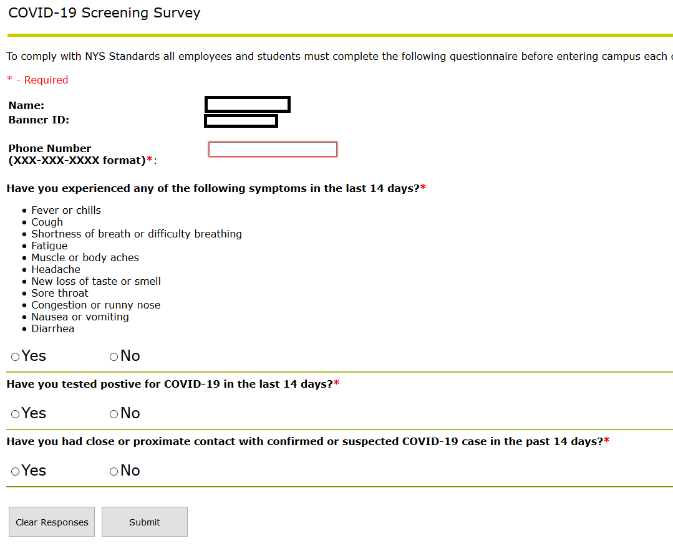
The employee’s name and Banner ID will automatically be populated. A phone number is required to be entered, this will be used in the event the Department of Health is required to do contract tracing.
If an employee answers YES to any of the questions the college may restrict entry to the campus.
Failure to complete the survey prior to arriving to campus will require the employee to complete the survey before being granted access to the campus.

Upon arriving to campus all employees will have their temperature taken. If the temperature is within the permitted range the employee is then required to be screened at the kiosk. The screening process confirms the submission of the survey and the answers provided. If the survey is not completed, the employee will be required to complete the survey at the screening kiosk.
All employees will be required to have their college ID and present it at the kiosk. The employee will swipe or scan their ID and this will retrieve today’s submission. Here is a screen shot of the kiosk:
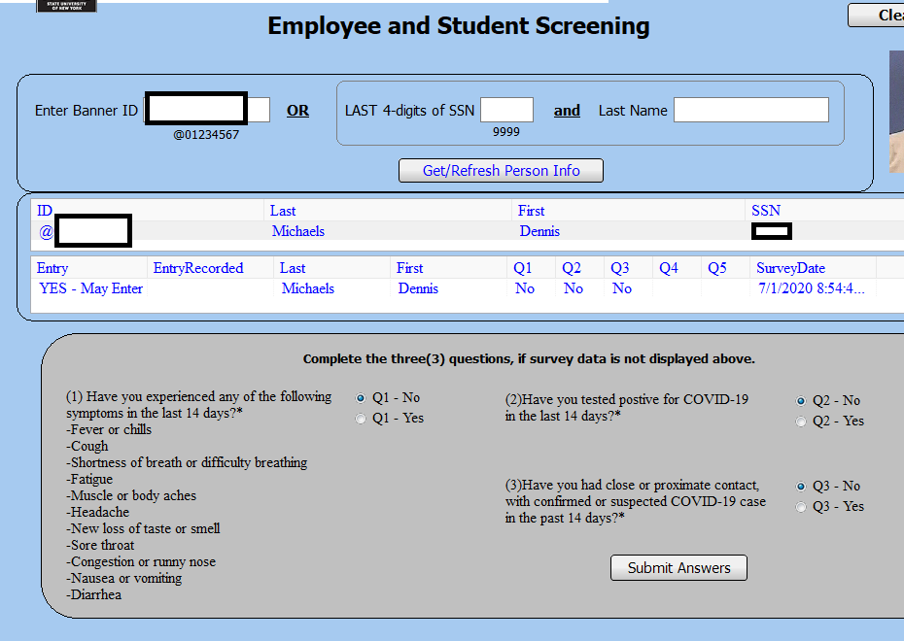
The screener can retrieve the employee’s record by either their Banner ID (manually entering it or by the swiping/scanning of the college ID), or the last four digits of their social security number and their last name. The employee in the screen shot has answered NO to all of the required questions and therefor is cleared to enter. There is button not shown above that the screener will press once confirming the employee is cleared to enter.
If no responses are presented after retrieving the record this confirms the employee did not complete the survey prior to entering the building. The screener will be required to ask the employee the required questions and complete the survey on their behalf. If the employee answered NO to all questions the screener will mark the employee cleared to enter the campus.
The data is stored in a secure database but no protected health information will be stored. The information will only be used to help prevent the spread of COVID-19 and for contact tracing in the event someone who was on campus tests positive.

