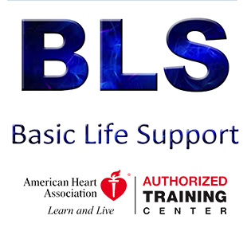
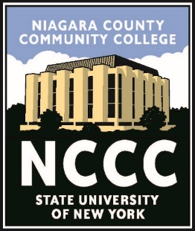
NIAGARA COUNTY COMMUNITY COLLEGE
Division of Workforce Development (716)614-6236
Basic Life Support Summer 2020

This American Heart Association CPR/AED course meets the training requirements for all Healthcare Providers and students. CPR/AED use, choking and rescue breathing for adults, children and infant practices are covered. Two-year American Heart Association card is given at completion. Class is typically 6 Hours. Cost is $75.

Location: Sanborn Fire Hall, 5811 Buffalo St, Sanborn
June 24 – Sanborn Fire Hall – 6:00 pm
June 27 – Sanborn Fire Hall – 9:00 am
NCCC Main Campus Science Annex Room CA-101
July 16th – 9:00 am
July 17th – 6:00 pm
July 23rd – 6:00 pm
July 24 – 9:00 am
July 30 – 9:00 am
July 31 – 6:00 pm
August 6 – 6:00 pm
August 7 – 9:00 am
August 8 – 9:00 am
August 13 – 6:00 pm
August 14 – 9:00 am
August 15 – 9:00 am
August 20 – 9:00 am
August 21 – 6:00 pm
Please call (716) 614-6236 to register or mail check or m.o. (payable to NCCC) to:
NCCC/Workforce Dev; 3111 Saunders Settlement Rd; Sanborn, NY 14132
along with your name, address, phone number, date of birth and date you are registering for.
http://www.niagaracc.suny.edu/conted/ems/bls.php

