- ADMISSIONS
  - About Us
  - Educational Opportunity Program
  - Financial Aid
  - Registration & Records
  - Scholarships
  - Transfer Partnerships
  - Tuition and Fees
  - Veteran Services
- ACADEMICS
  - Academic Calendar
  - Academic Center for Excellence
  - Academic Divisions
    - Business, Technology and the Arts
    - Hospitality, Tourism and Culinary Arts
    - Humanities and Social Sciences
    - Nursing and Allied Health
    - Science, Health and Mathematics
  - Academic Programs
  - Career & Transfer
  - Catalog
  - Course Offerings
  - Library
  - Online Learning
  - Registration & Records
  - Workforce Development
- CAMPUS LIFE
  - Dining Services
  - Housing
  - Public Safety
    - Emergency Alerts
    - School Closings and Cancellations
  - Student Life
  - Student Services
  - Upcoming Events
  - Wellness Center
- ATHLETICS
- COMMUNITY

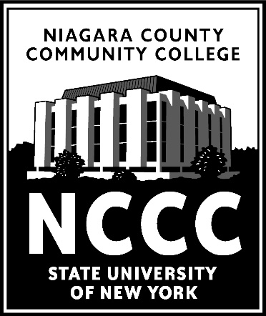

CAP ELECTRONIC REGISTRATION FORM INSTRUCTIONS
To register for NCCC CAP classes, please follow the steps outlined below:

Step 1: Click on the link below to begin the CAP Registration Process.

Go to: https://www.niagaracc.suny.edu/academics/highschool/ and then click on the blue box that states: “Apply to CAP Today”.

Step 2: Log In Instructions: Returning students will need their log in credentials from last year. New registrants must first create an account with Next Gen by clicking on “Create New Account” on the login page.

Step 3: Courses – select your courses from XXX High School Fall 2021 CAP Courses.

Step 4: Ensure that the form is fully completed. Electronically sign the form.

Students will receive an invoice in the mail. Payment instructions will be included. Students/Families can pay electronically or by check.

